Task 3: Protein Structure Prediction.
Title: Protein Structure Prediction and Structural Analysis of Human TERT Protein.
Protein Details:
- Protein Name: Telomerase reverse transcriptase (TERT)
- Organism: Homo sapiens
- UniProt ID: 014746
- AlphaFold Entry: AF-014746-F1

Aim: To predict and analyze the three-dimensional structure of the TERT protein using AlphaFold DB and visualize it in PyMOL.

Tools Used:
- https://www.uniprot.org
- https://alphafold.ebi.ac.uk
- pymol.org

Procedure:
- The amino acid sequence of TERT protein was obtained from uniprot.org
- The predicted 3D structure was retrieved from AlphaFold DB.
- The PDB file was downloaded and opened in pymol.org.
- Cartoon representation and spectrum coloring were applied for visualization.
- Structural images were captured from different orientations.

Structural Features:
- The predicted structure contains multiple alpha-helices and loop regions.
- The protein exhibits a compact folded conformation.
- High-confidence regions were observed in the catalytic core domain.
- Flexible loop regions indicate possible functional mobility.
- Spectrum coloring in PyMol helped identify structural organization clearly.
- The structure is associated with telomere maintenance and chromosome stability.

Results: The 3D structure of the TERT protein was successfully visualized using PyMOL. Different structural regions including helices, loops, and conserved domains were identified clearly.

Conclusion: AlphaFold DB successfully predicted the tertiary structure of the TERT protein. Structural visualization using PyMOL provided insight into the folding pattern and functional regions of the protein.

Attach These Image in Submission:
Image 1 – UniProt Page
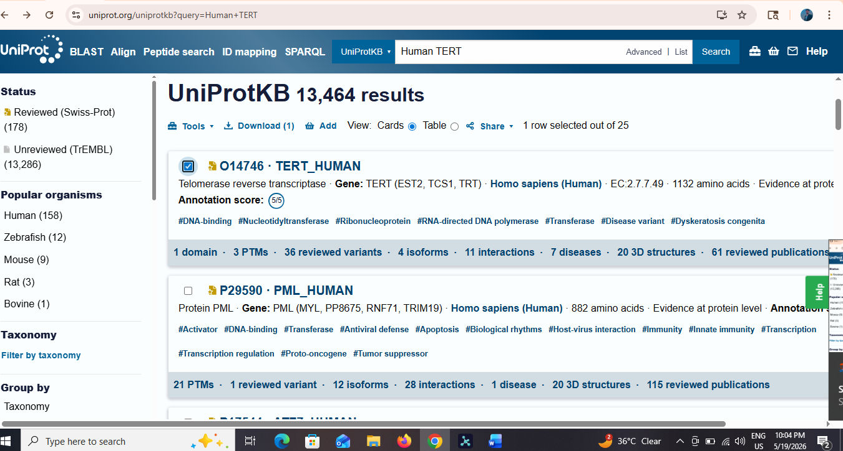
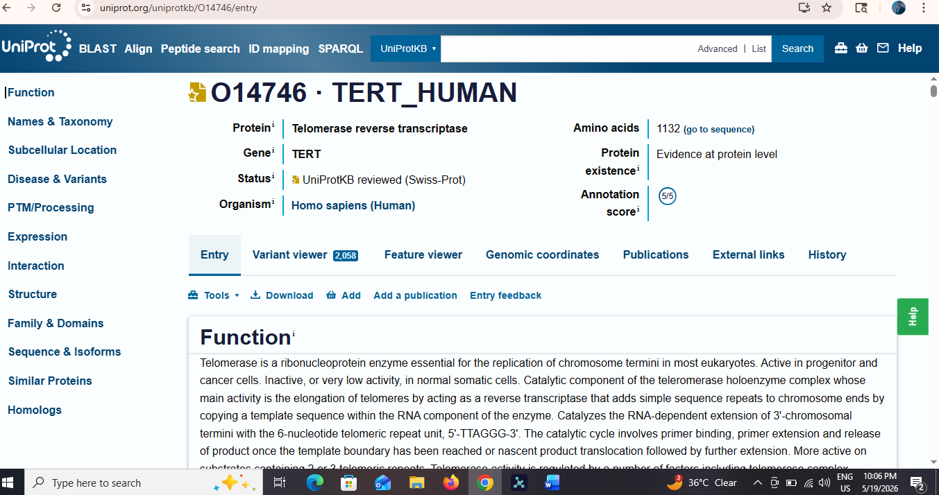

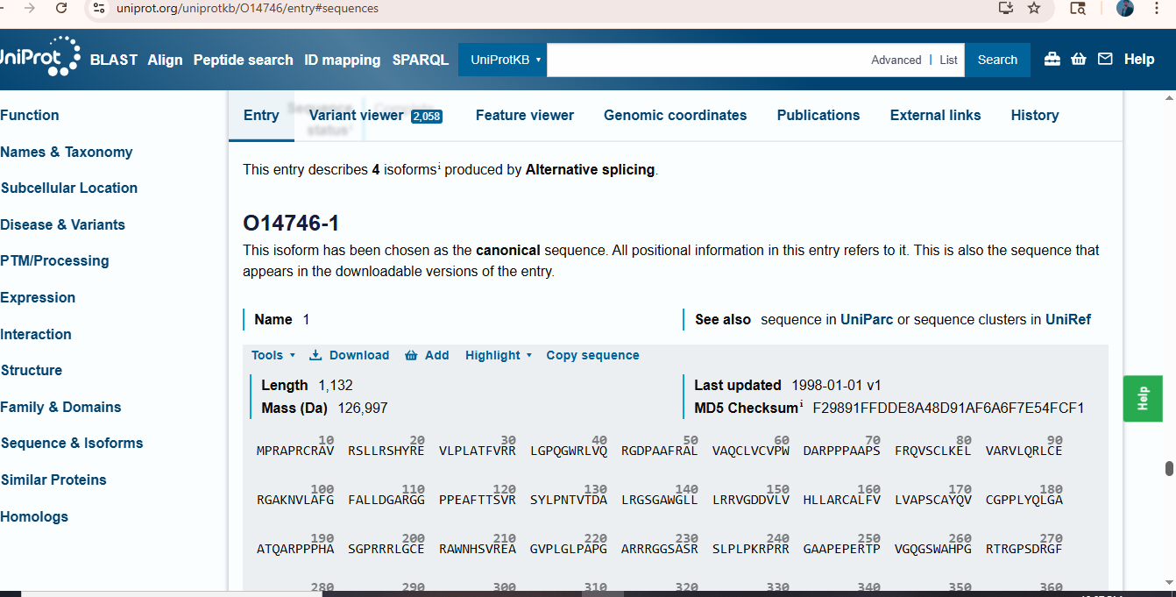

In Retrieval of the TERT protein sequence from https://www.uniprot.org database using UniProt ID 014746.

Image 2 – AlphaFold Structure
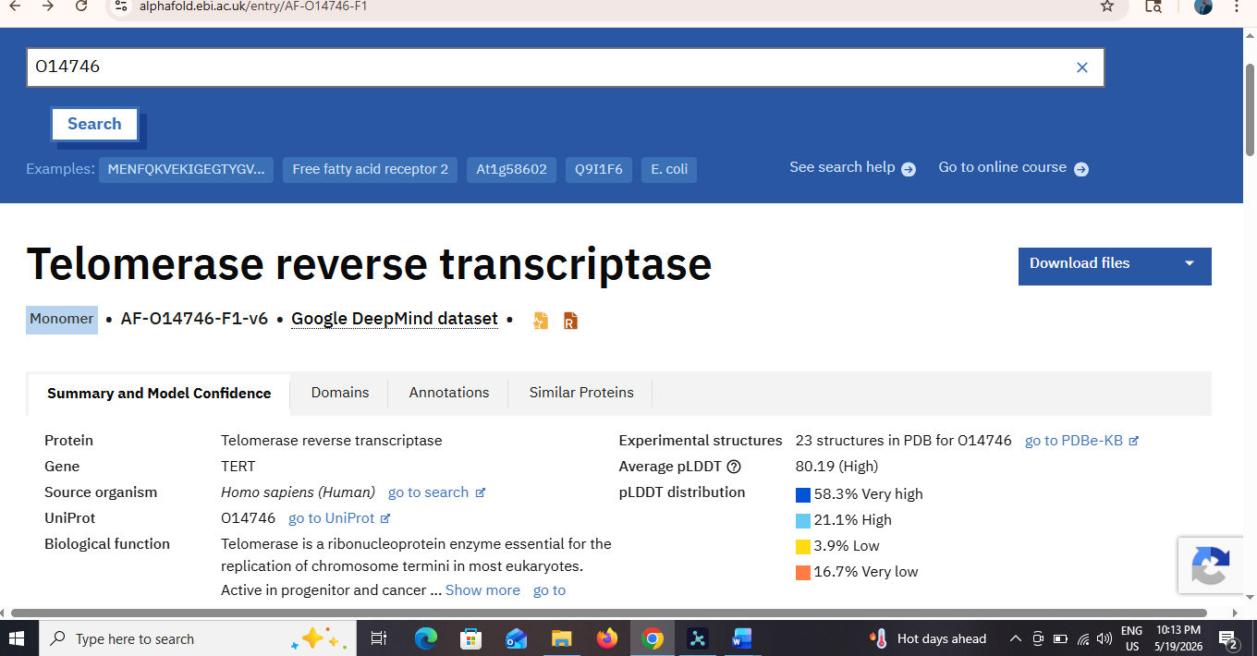

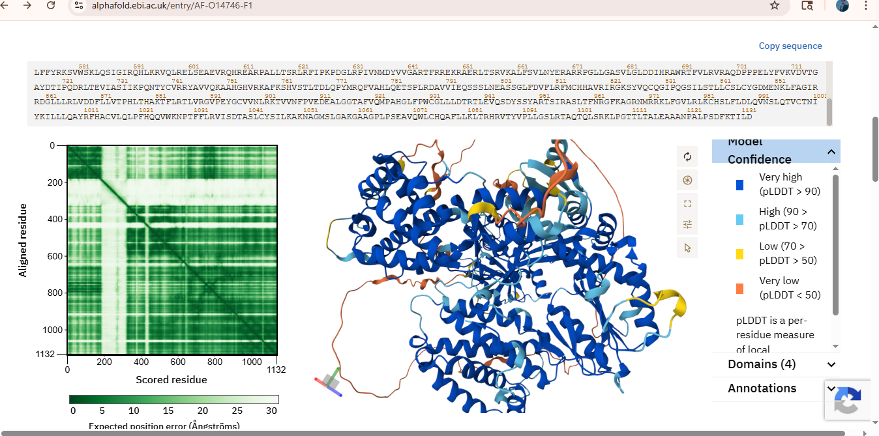

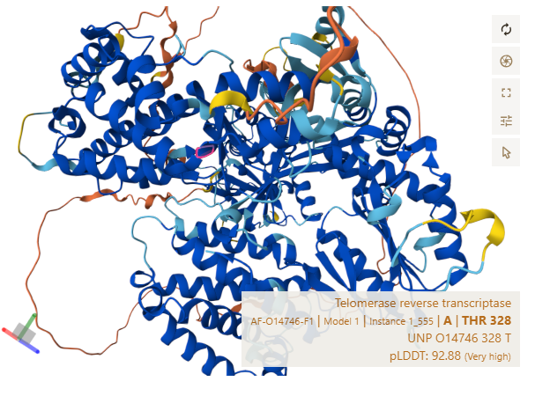

In Predicted 3D structure of the TERT protein obtained from https://alphafold.ebi.ac.uk .

Image 3 – PyMOL Front View

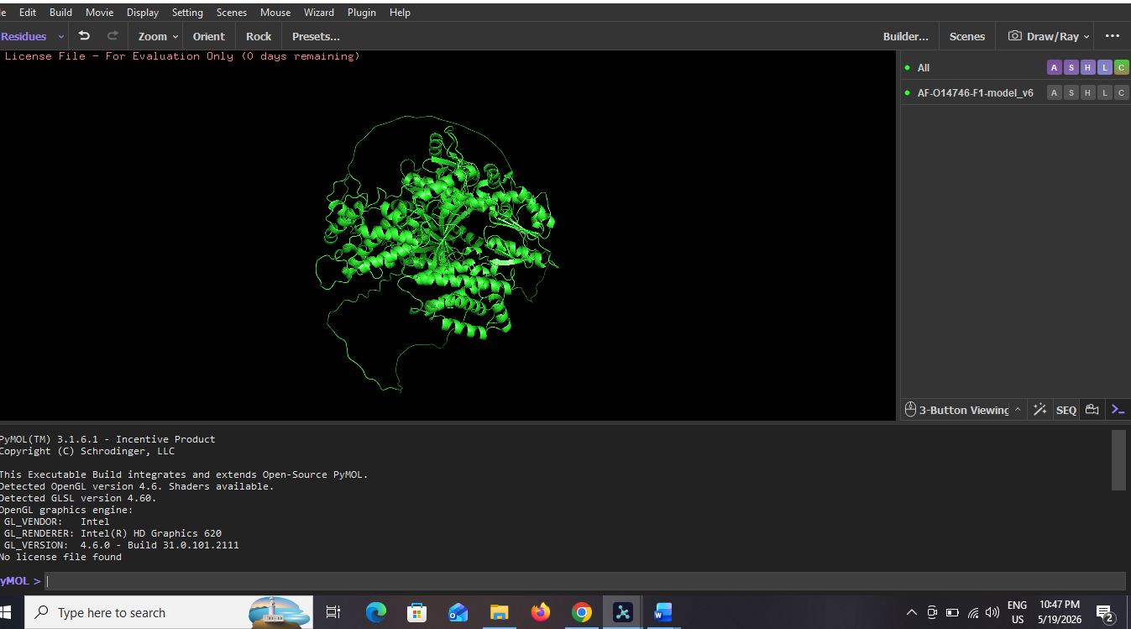

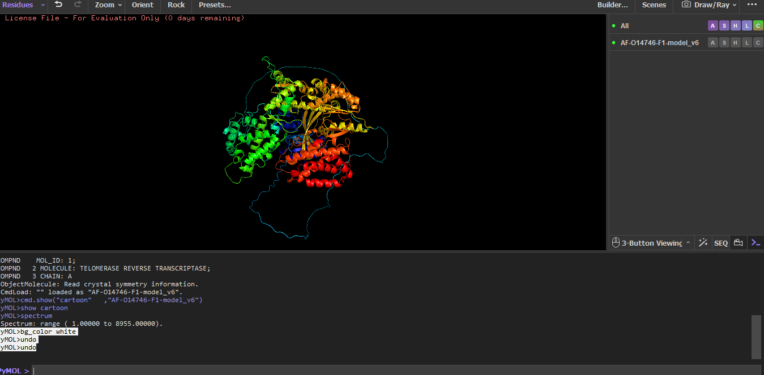

In The Front view visualization of the TERT protein structure in PyMOL using ctoon representation.

Image 4 – Side View

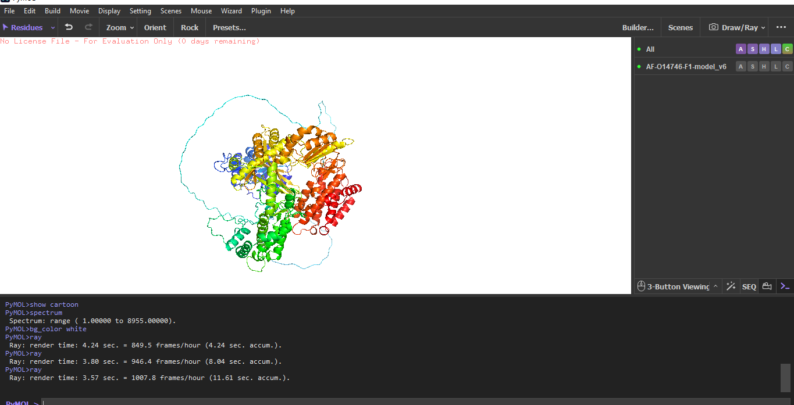

In the Side view of the predicted TERT protein structure showing folding arrangement and structural organization.

Image 5 – Colored Structure

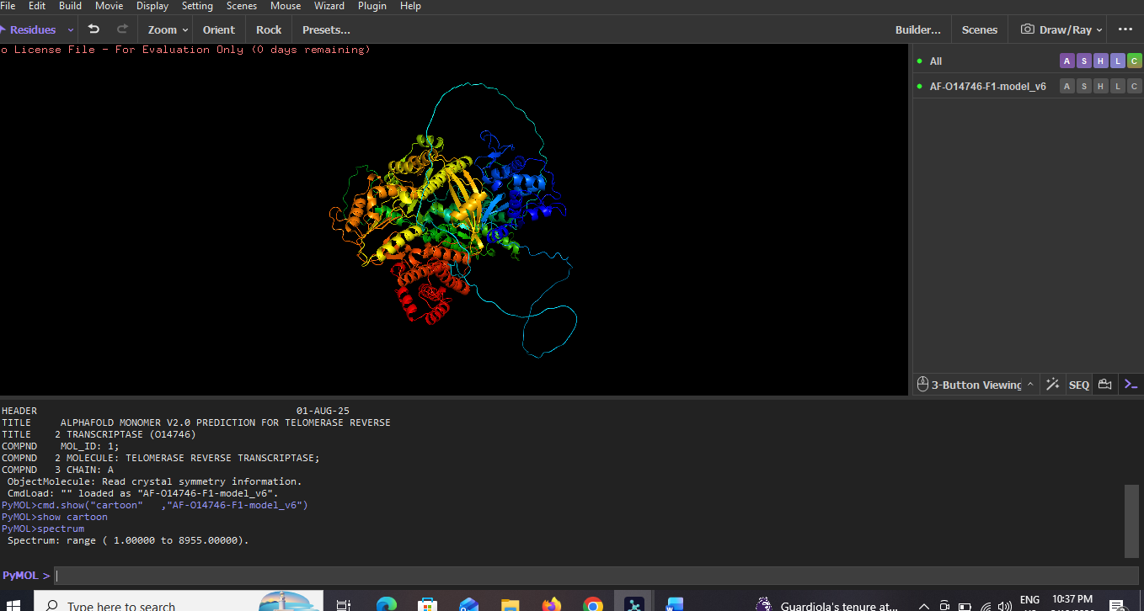

Spectrum colored representation of the TERT protein highlighting different structural regions and domains.

